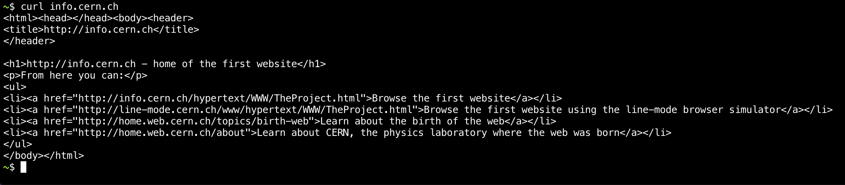

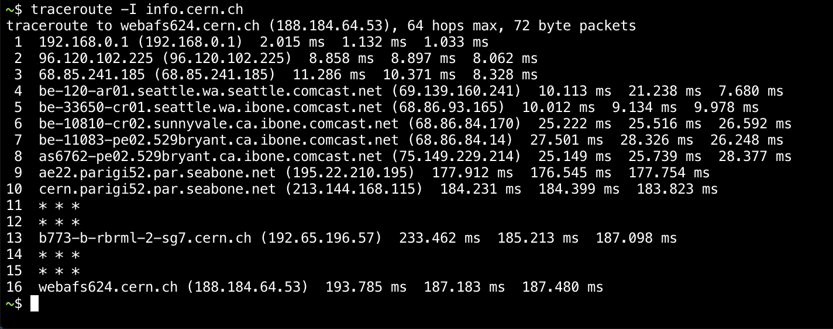

Step3.
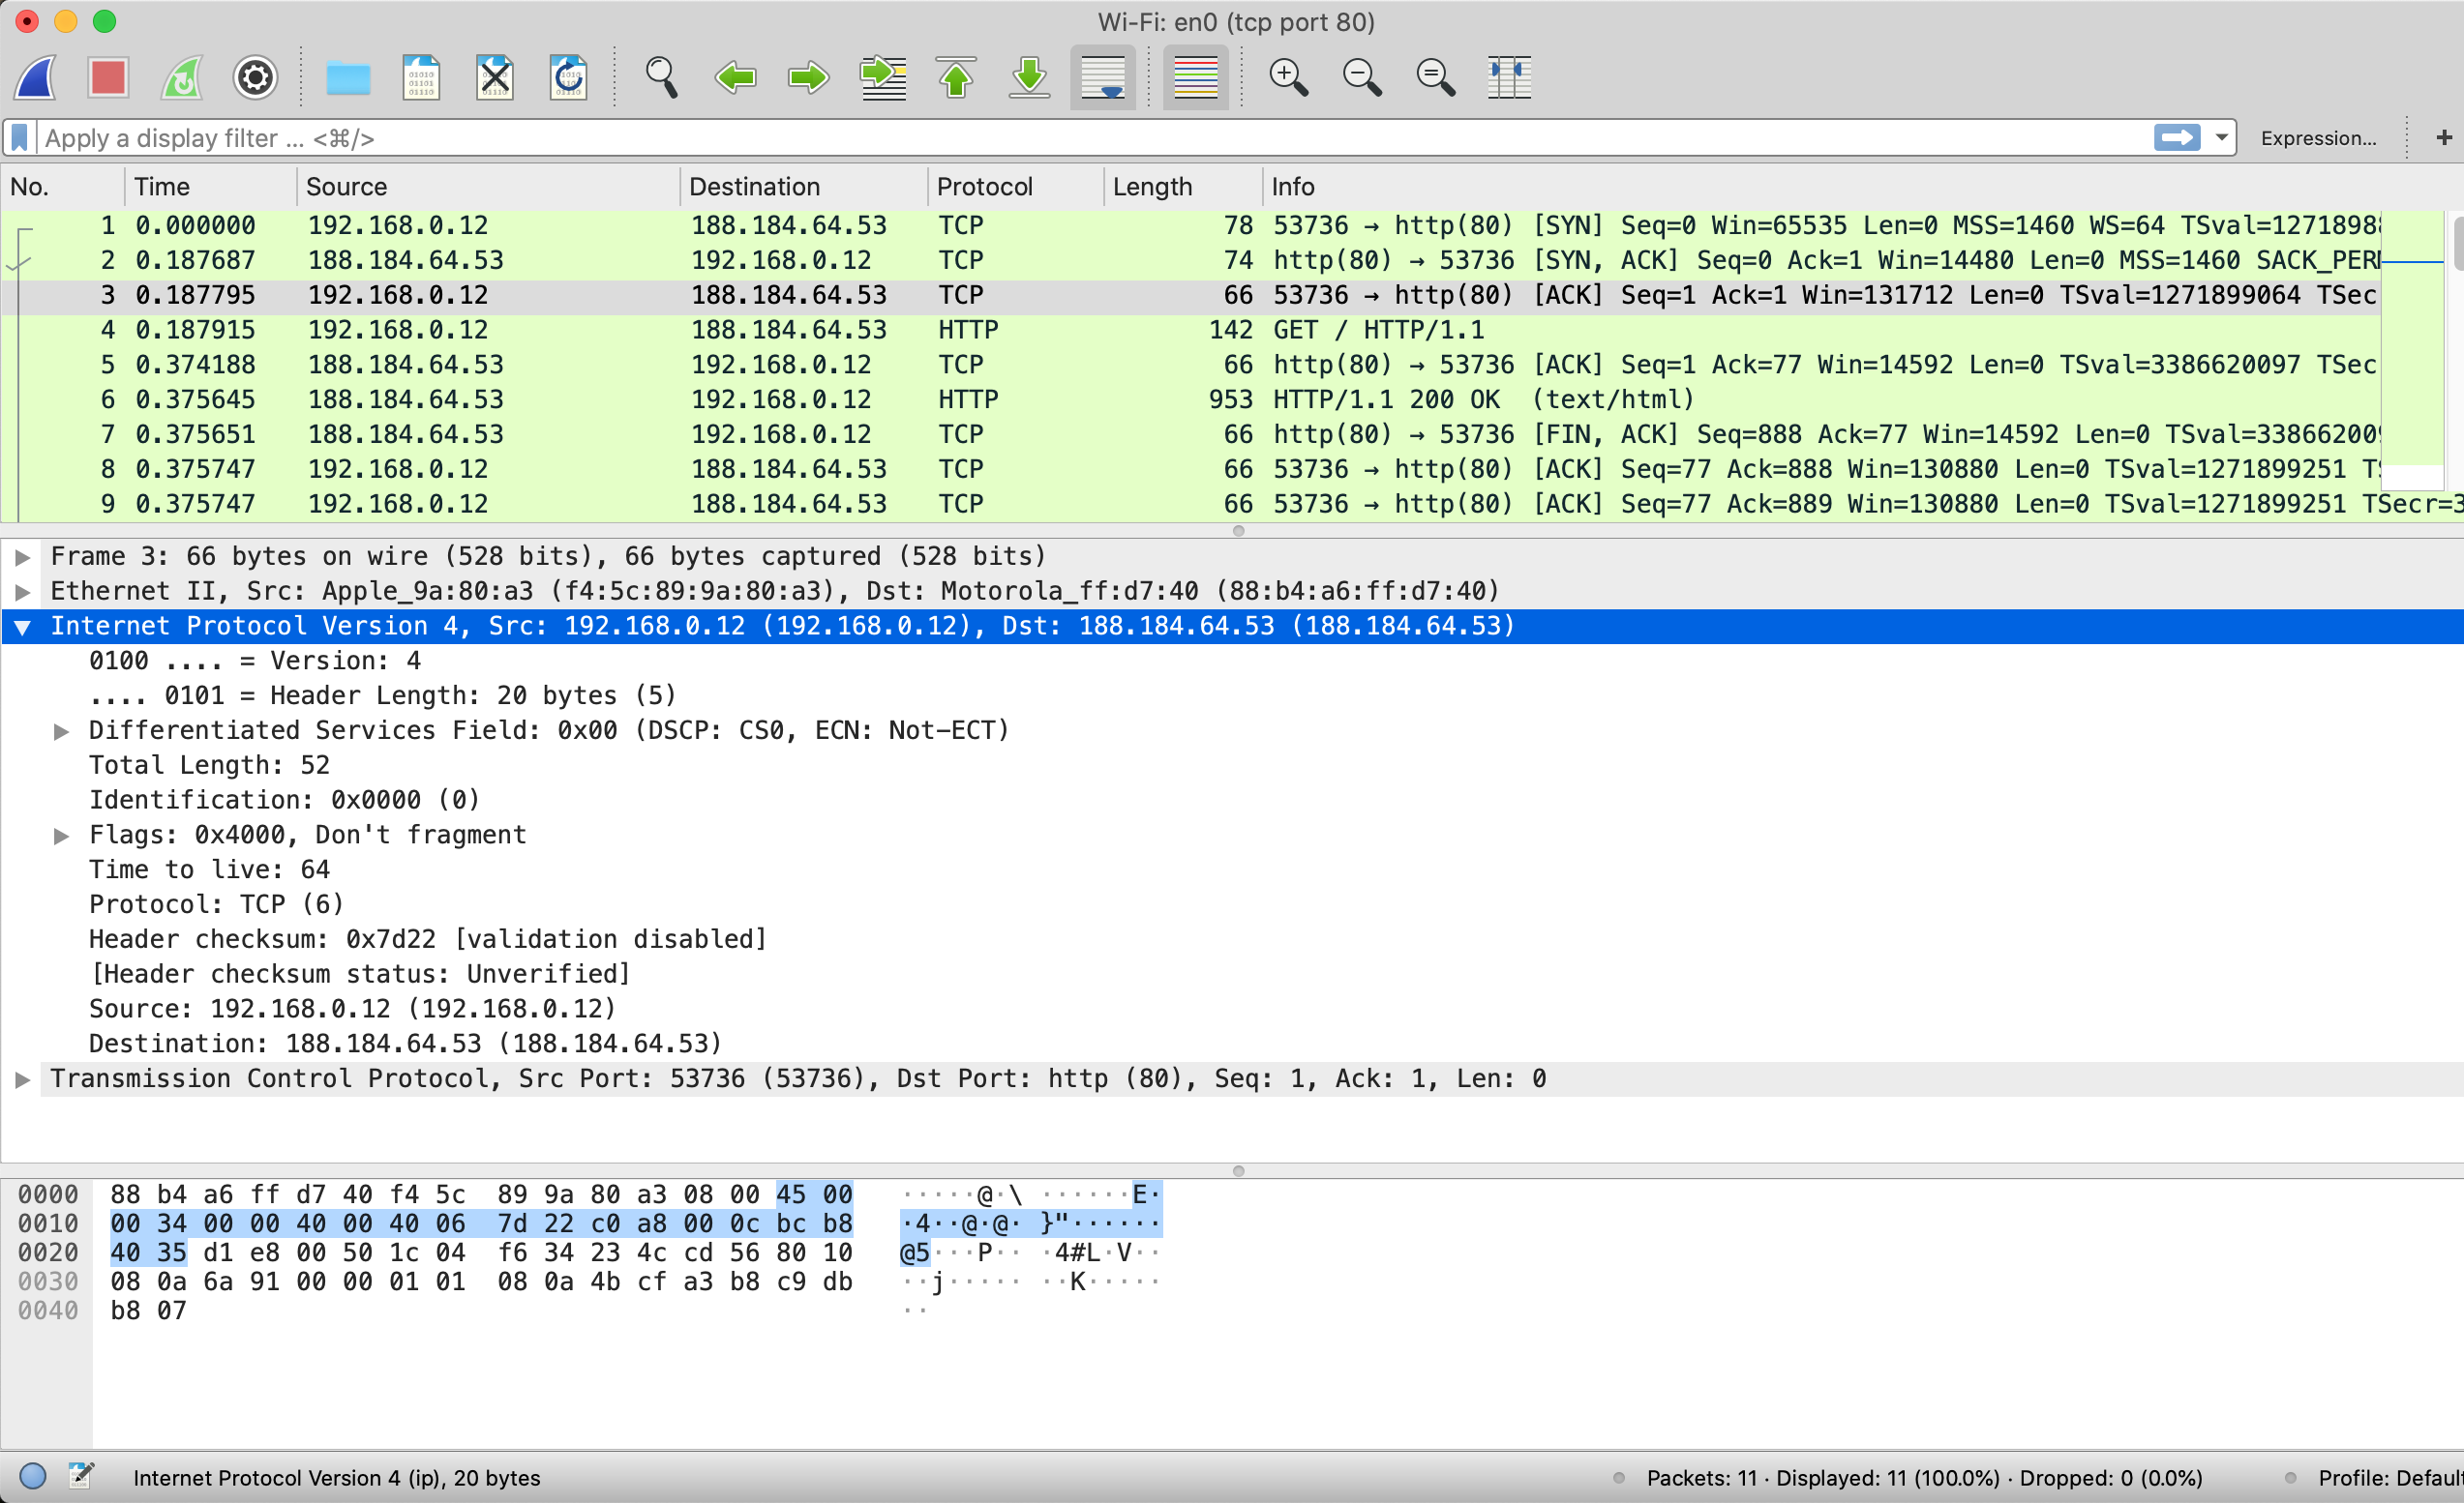

1. What are the IP addresses of your computer and the remote server?
My computer: 192.168.0.12
Remote server: 188.184.64.53

2. Does the Total Length field include the IP header plus IP payload, or just the IP payload?
Include IP header plus IP payload

3. How does the value of the Identification field change or stay the same for different packets? For instance, does it hold the same value for all packets in a TCP connection or does it differ for each packet? Is it the same in both directions? Can you see any pattern if the value does change?
No hold the same value for all packets in a TCP connection.
Yes, both directions no hold the same value for all packets.
Some fields like Time to live and Header checksum always change

4. What is the initial value of the TTL field for packets sent from your computer? Is it the maximum possible value, or some lower value?
64.
Not maximum possible value, it’s some lower value.

5. How can you tell from looking at a packet that it has not been fragmented? Most often IP packets in normal operation are not fragmented. But the receiver must have a way to be sure. Hint: you may need to read your text to confirm a guess.
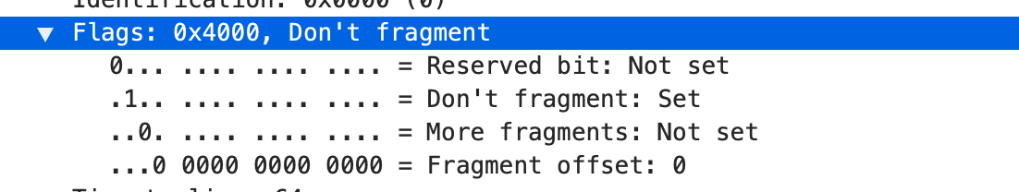

6. What is the length of the IP Header and how is this encoded in the header length field? Hint: notice that only 4 bits are used for this field, as the version takes up the other 4 bits of the byte. You may guess and check your text.
Length of IP Header:

Drawing of IP packet:
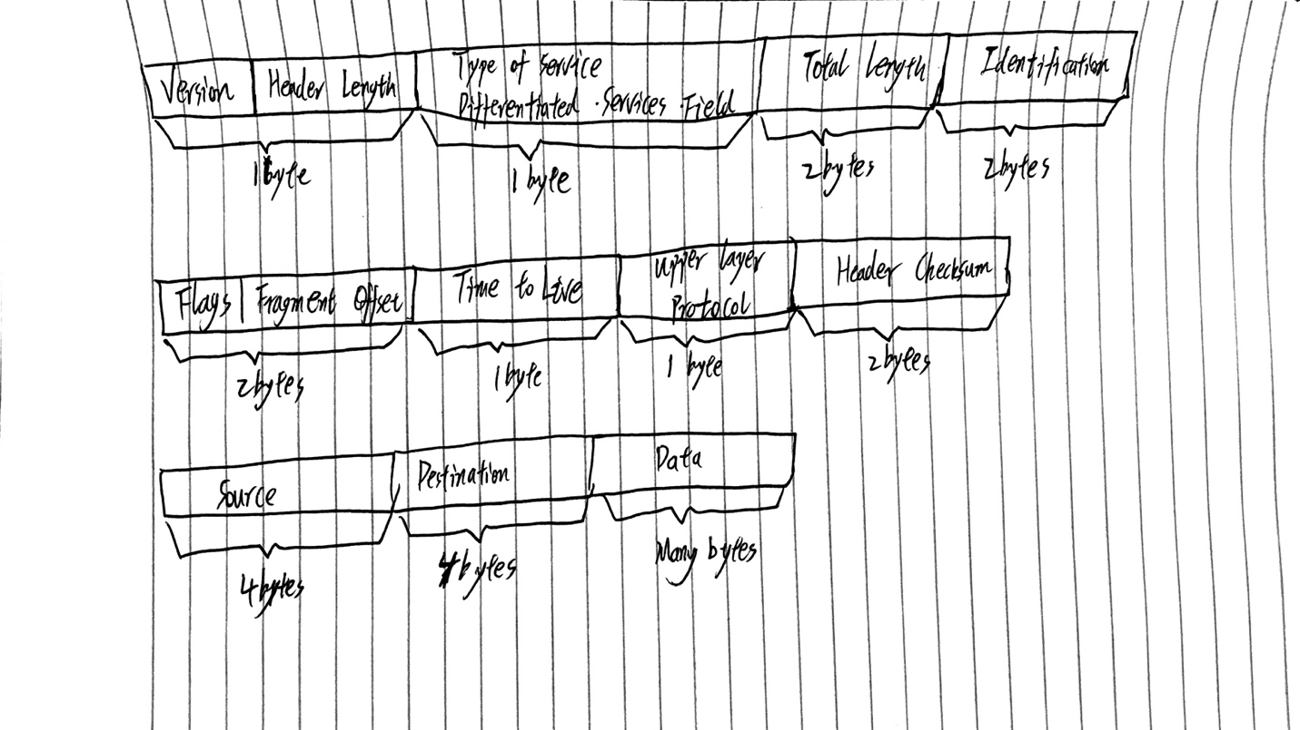
Hand in your drawing of an IP packet and the answers to the questions above.

Step4.

Traceroute output:
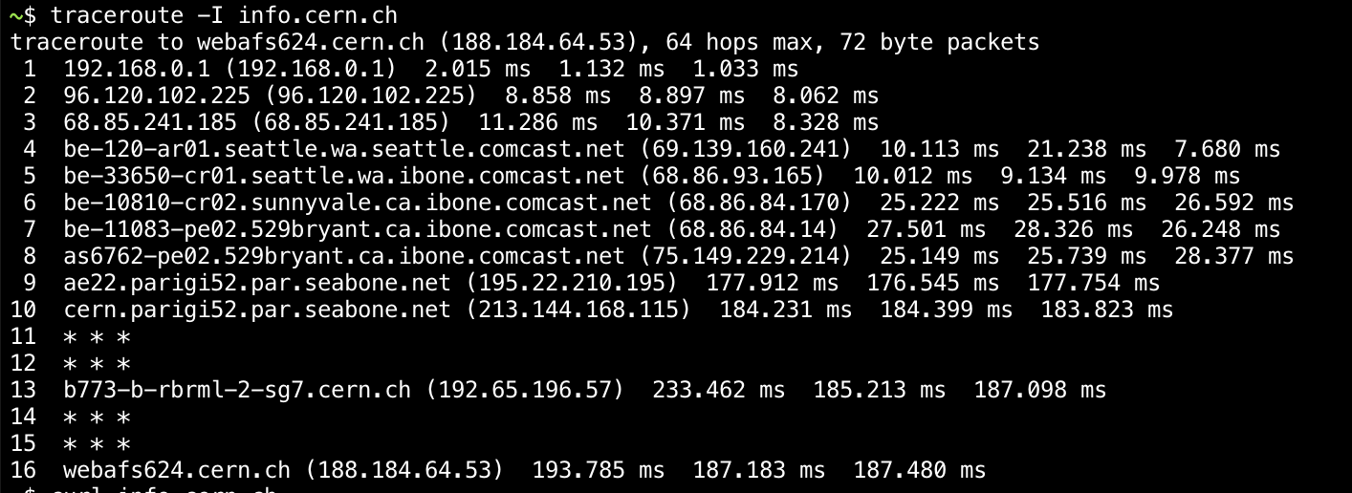

Drawing of netword path:

Hand in your drawing, and traceroute output if it was not supplied to you.

Step5.
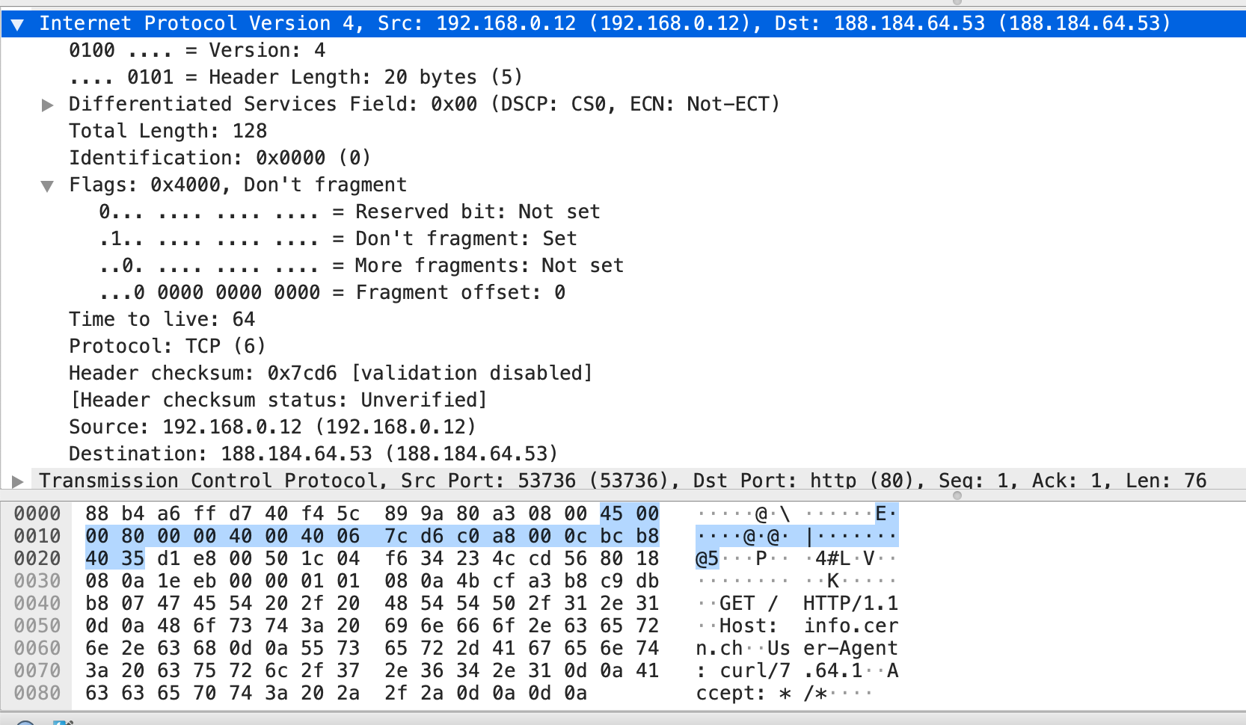

1. Divide the header into 10 two byte (16 bit) words. Each word will be 4 hexadecimal digits shown in the packet data panel in the bottom of the Wireshark window, e.g., 05 8c
45 00, 00 80, 00 00, 40 00, 40 06, 7c d6, c0 a8, 00 0c, bc b8, 40 35
45 00 + 00 80 = 45 80
45 80 + 00 00 = 45 80
45 80 + 40 00 = 85 80
85 80 + 40 06 = c5 86
c5 86 + 7c d6 = 1 42 5c
1 42 5c + c0 a8 = 2 03 04
2 03 04 + 00 0c = 2 03 01
2 03 01 + bc b8 = 2 bf c8
2 bf c8 + 40 35 = 2 ff fd

2. Add these 10 words using regular addition. You may add them with a hexadecimal calculator (Google to find one), or convert them to decimal, add them, and convert them back to hexadec- imal. Do whatever is easiest.
2 ff fd

3. To compute the 1s complement sum from your addition so far, take any leading digits (beyond the 4 digits of the word size) and add them back to the remainder. For example: 5a432 will be- come a432 + 5 = a437.
00 02 + ff fd = ff ff
ff ff

4. The end result should be 0xffff. This is actually zero in 1s complement form, or more precise- ly 0xffff is -0 (negative zero) while 0x0000 is +0 (positive zero).
0xffff

Hand in your sums. Next to each word you add note the IPv4 fields to which it corresponds.

